**Project For AWS Cloud Practitioner**

**Kishor Katore**

**Step 1:- Launched two EC2 Instances of the amazon linux AMI with Basic Web Application (Apache) installed**

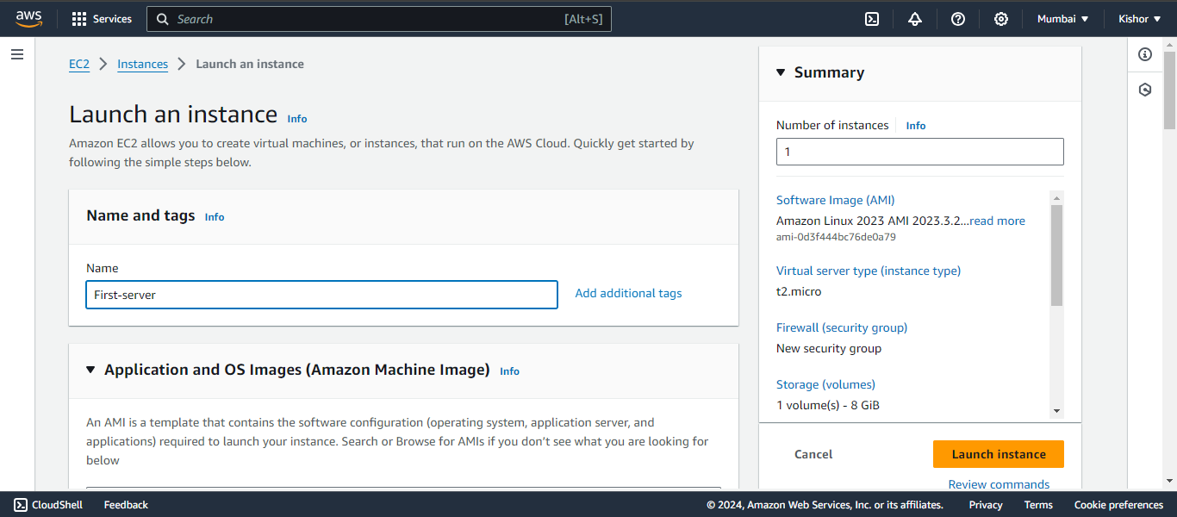

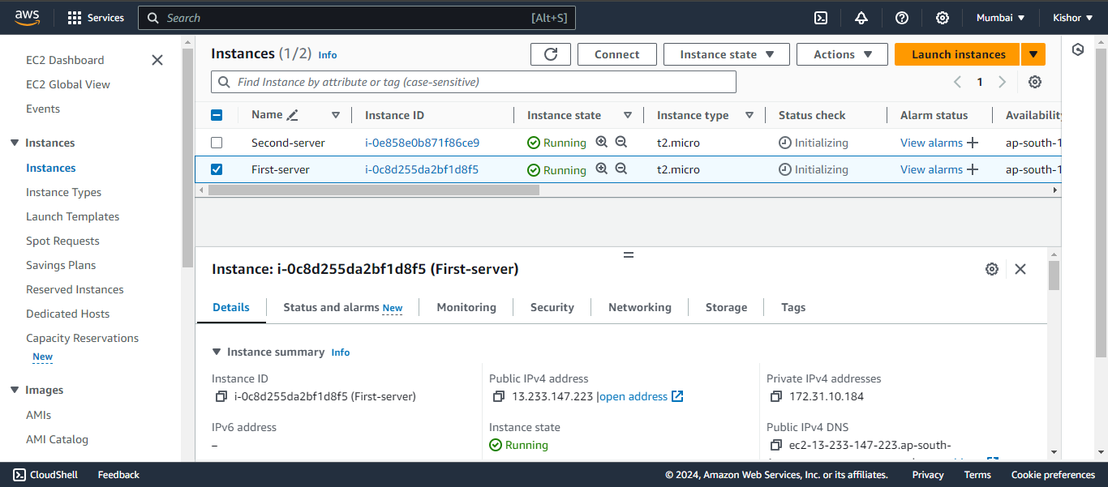

* **Step 2: Created Target Group of EC2 instances**

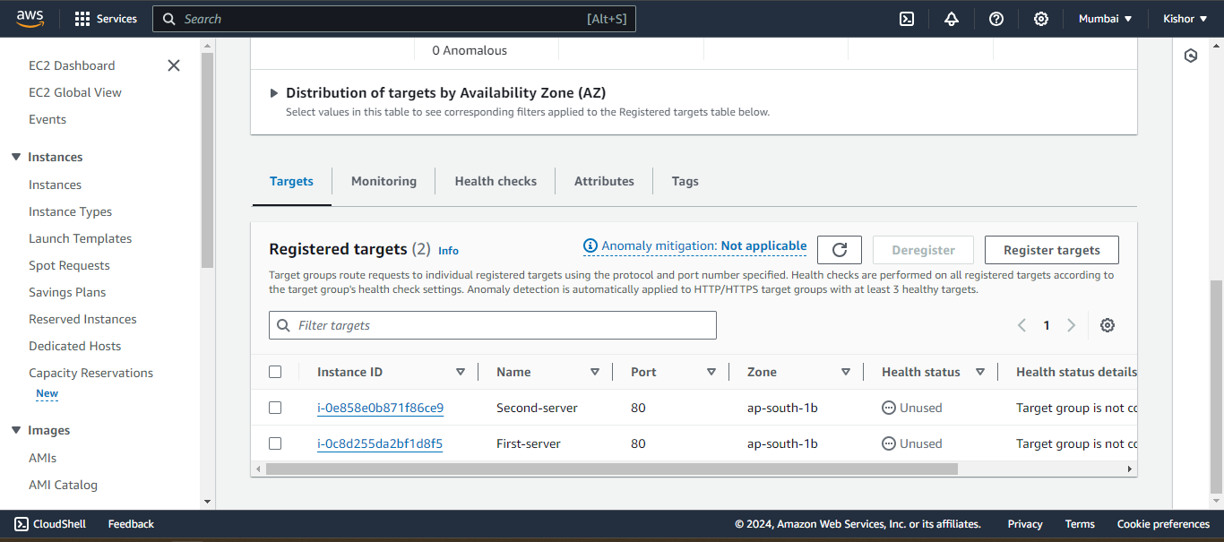

* **Step 3: Created load balancer to balance the traffic equally.**

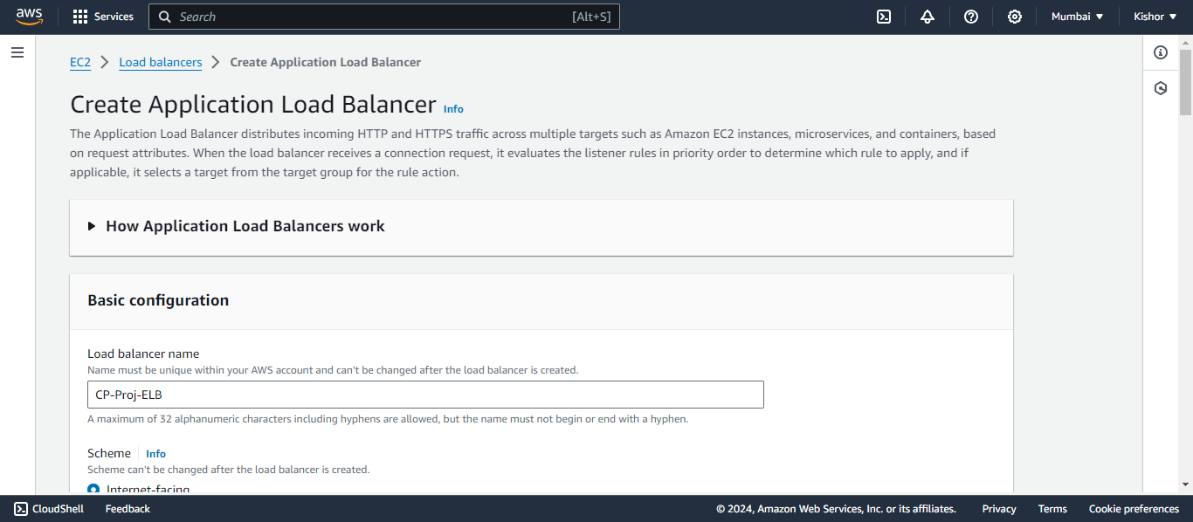

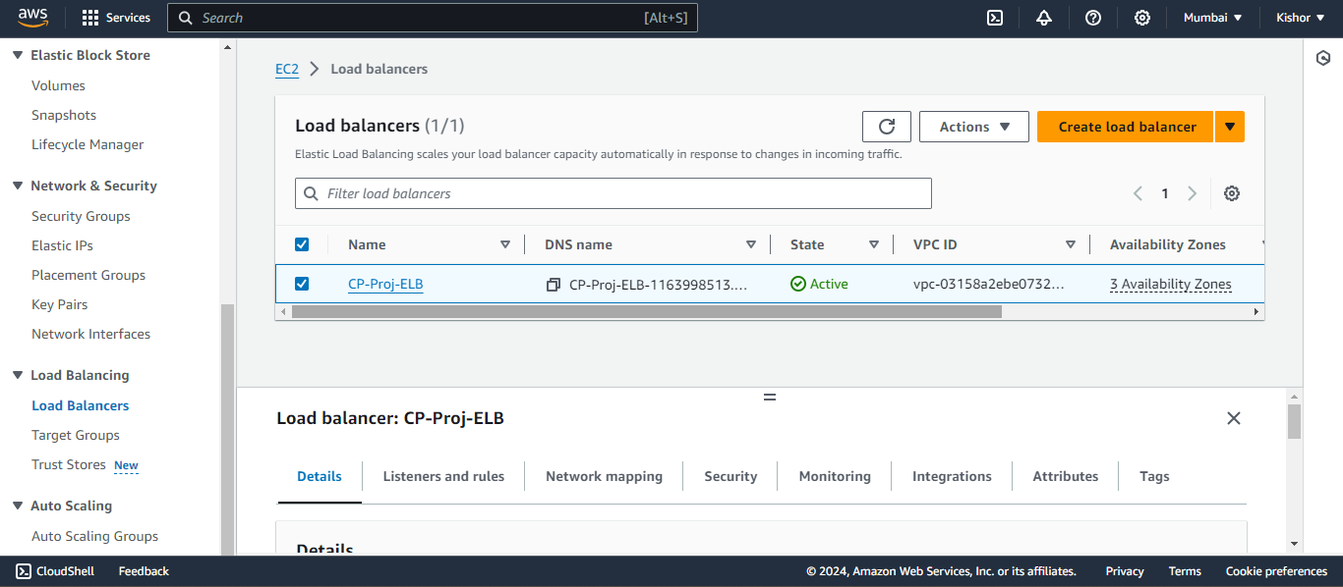

* **Step 4: Checking Web server Traffic Distributing to both server**

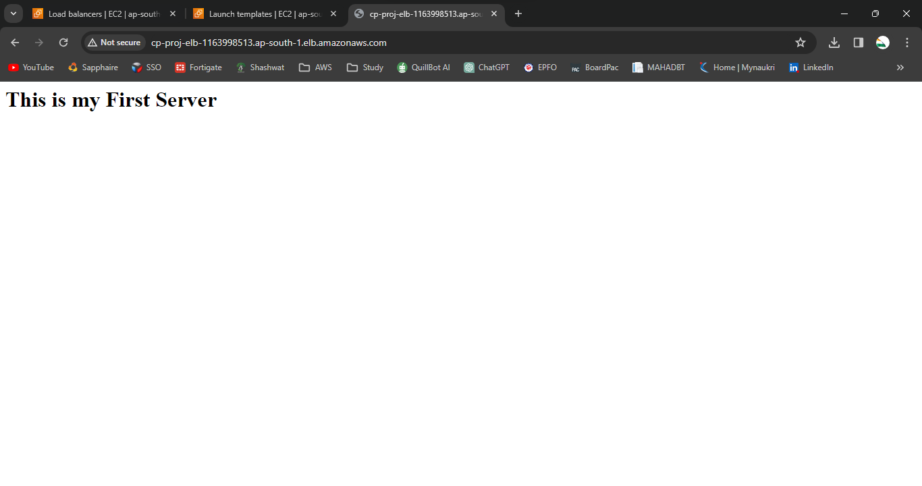

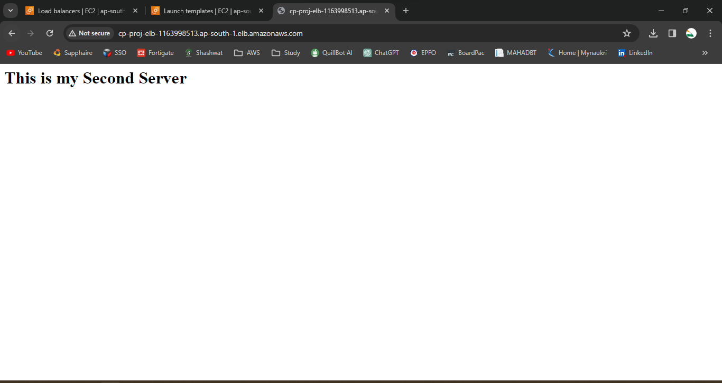

* **Step 5: Created Launch Template for attaching Autoscalling Group**

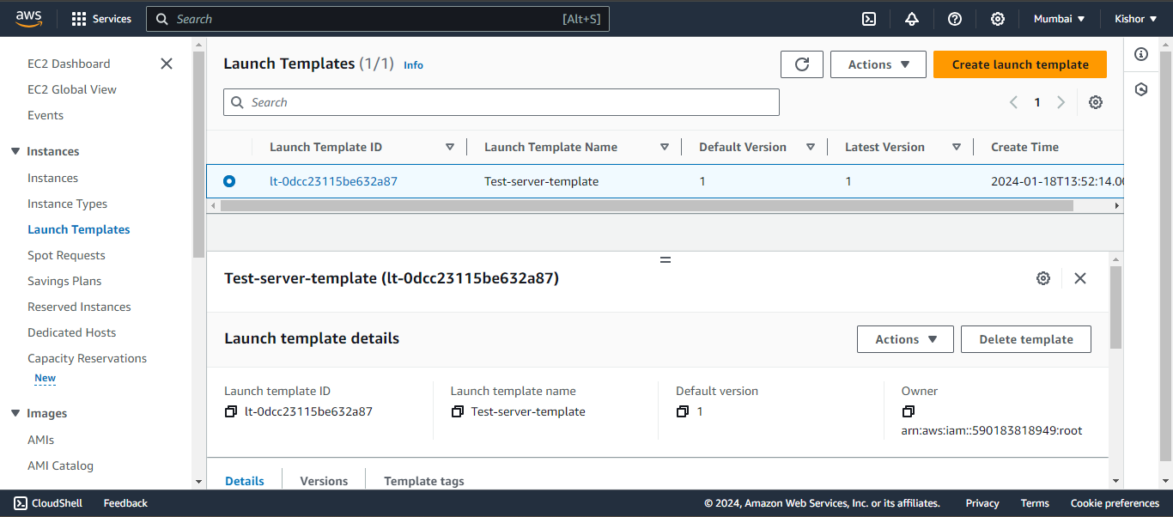

* **Step 6: Created Autoscaling Group with the limit of 2 instance to be launched**

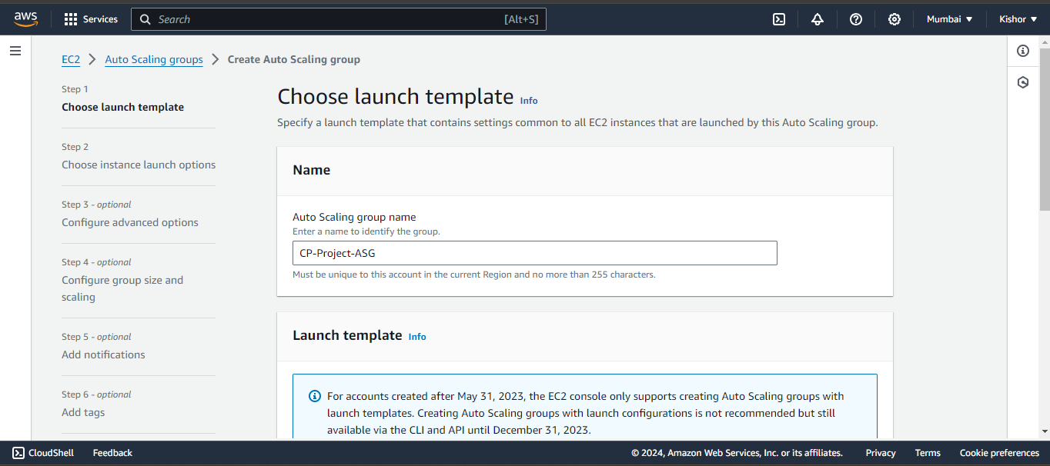

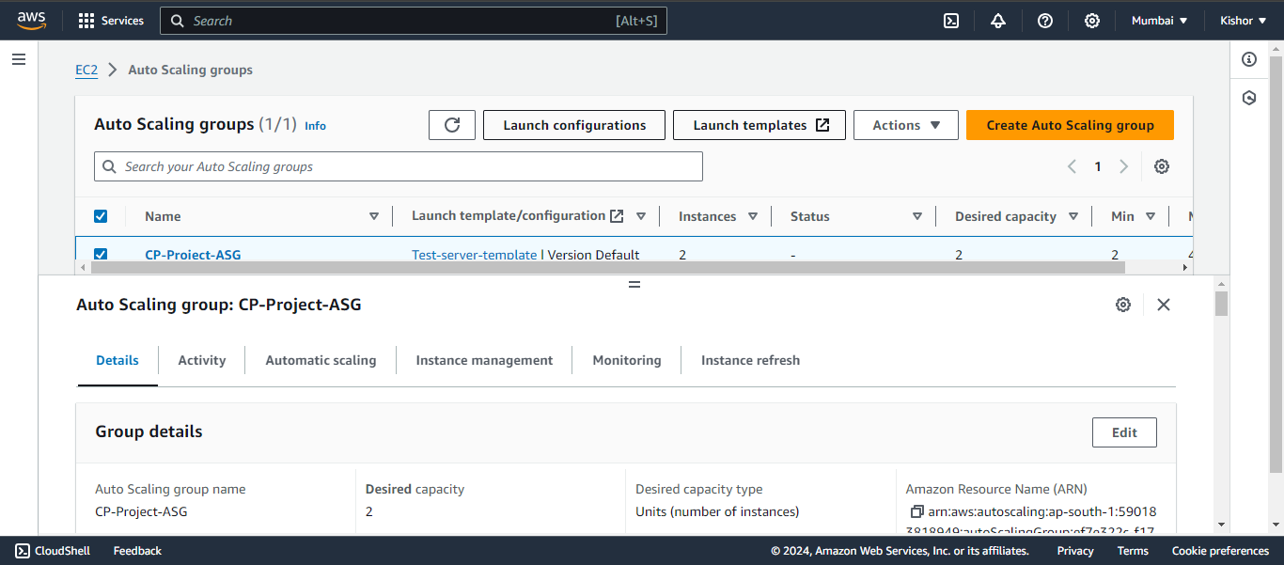

* **Step 7: Two instance launched automatically with the help of auto scaling group.**

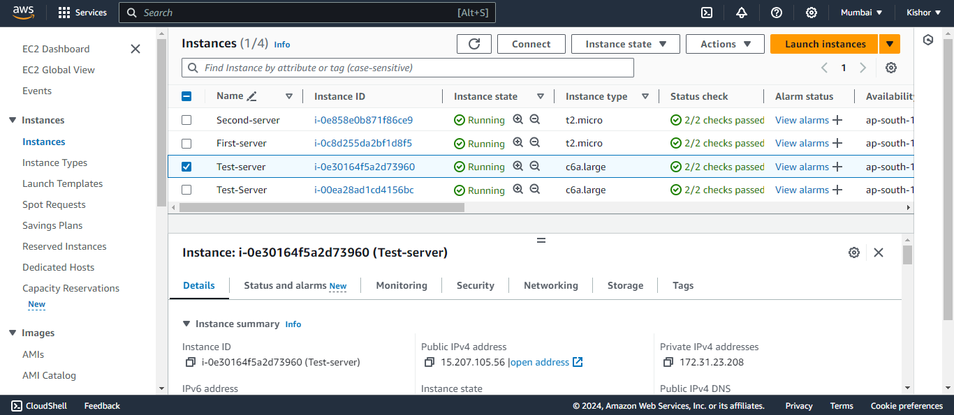

* **Step 8: After creating auto scaling tested the final server named as (Test Server).**

